**This submission is original work and no part is plagiarized** (signed)

Gaurav Pahwa (Date) 18/08/2021



**MECHANICAL ENGINEERING DEPARTMENT**

**Thapar Institute of Engineering and Technology, Patiala**

**Assignment - 1**

**Dynamics for the Mangonel-No Drag**

***UTA016 Engineering Design Project-I***



**Assignment - 1**

**Dynamics for the Mangonel - No Drag**

The following assignment has been based on the lecture on projectile dynamics for the Mangonel -with **No drag**. Complete the following **individually, copying will be dealt with severely**.

**Notes:**

1. Ensure on all graphs the curve is visible and sufficient resolution is provided so that the height and distance is determinable. The following chart is an example for 70 degrees at 22 m/s.

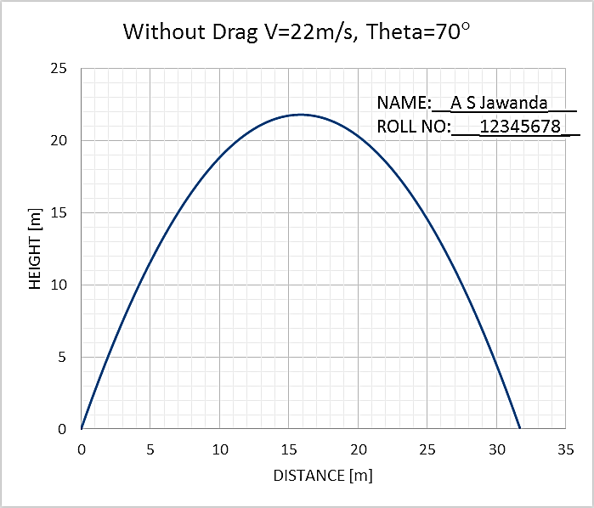

**Note: Compulsory** to Add Text box of Name and Roll No to every graph as shown.

1. **The excel graph and results for: One Launch angle in degrees, velocity in m/s have to be shown for evaluation on the same day.** While the remaining part of assignment is to be submitted within is to be submitted before next Tutorial class (if it is a holiday, then as instructed).
2. Do not leave this assignment until the last minute to find you have some IT issue.

Enjoy the assignment and try to think around the subject as much as possible and take from it any tips that you might use with your own Mangonel design.

**Marking Scheme:**

**Tutorial 1 Total = 5 Marks**

**Evaluation at end of Tutorial class = 2.5**

**Home evaluation = 2.5**

**TUTORIAL CLASS EVALUATION**

**Only Q1a below evaluated at the end of tutorial class on computer.**

**Point five Marks each for: [2.5 Marks]**

1. Excel sheet formulation,
2. Layout,
3. Graph series,
4. Graph clarity and
5. Graph format, as given in note.

***NOTE: Compulsory*** *to Add Text box of Name and Roll No to every graph as shown.*

1. Using the Excel spread sheet that you have developed to model the dynamics of a “missile” cast by the Mangonel, copy and paste graphs for the following into this document
   1. No drag: Launch angle 25 degrees, velocity 15m/s

<Insert Graph>

* 1. No drag: Launch angle 35 degrees, velocity 15m/s

<Insert Graph>

* 1. No drag: Launch angle 45 degrees, velocity 15m/s

<Insert Graph>

* 1. No drag: Launch angle 65 degrees, velocity 15m/s

<Insert Graph>

* 1. No drag: Launch angle 75 degrees, velocity 15m/s

<Insert Graph>

1. Plot a combined graph for No drag: Launch velocity 25m/s for angle varying from 20 degrees to 80 degrees in step of 5 degrees.
2. Plot a combined graph for No drag: Angle 30 degrees and launch velocity varying from 10m/s to 60 m/s in step of 10 m/s.
3. For the combined graphs in Q1, Q2 and Q3 comment on the effect of angle of launch and velocity on the horizontal distance travelled. (HANDWRITTEN ONLY)

|  |
| --- |
|  |
|  |
|  |
|  |
|  |
|  |
|  |
|  |
|  |
|  |
|  |
|  |
|  |
|  |
|  |
|  |
|  |
|  |

**Q1(a)**

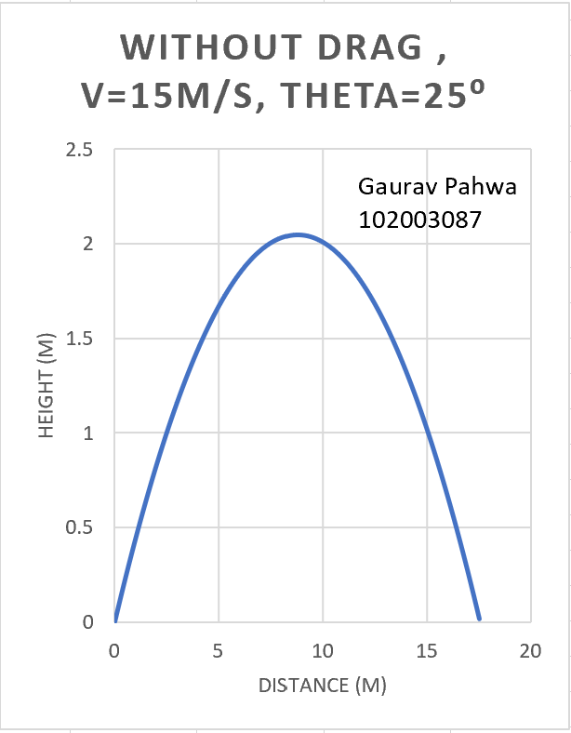

**Q1(b)**

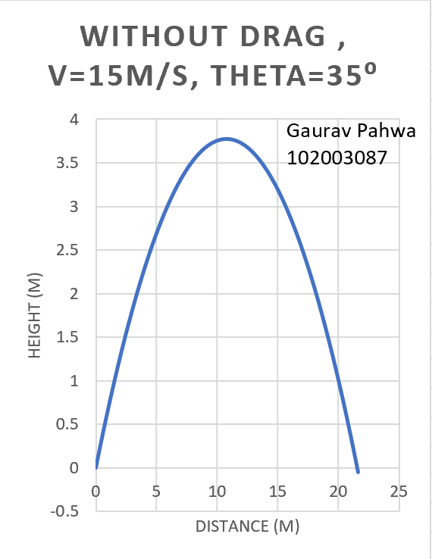

**Q1(c)**

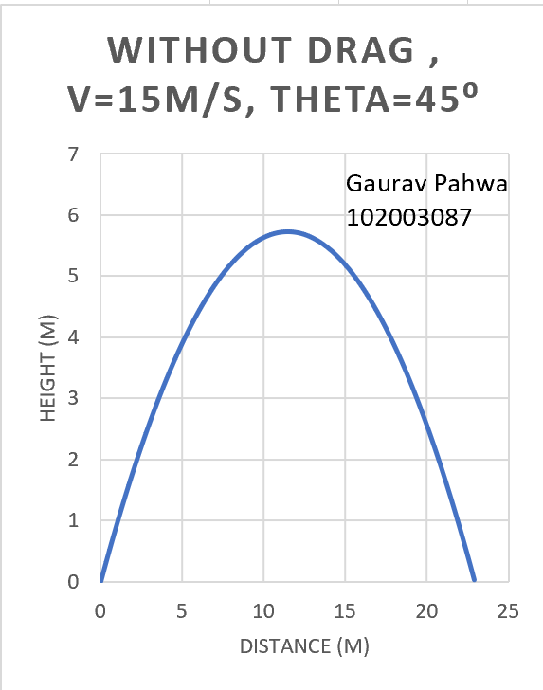

**Q1(d)**

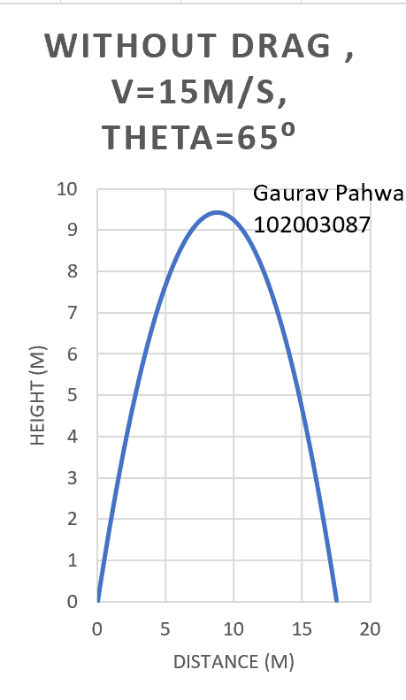

**Q1(e)**

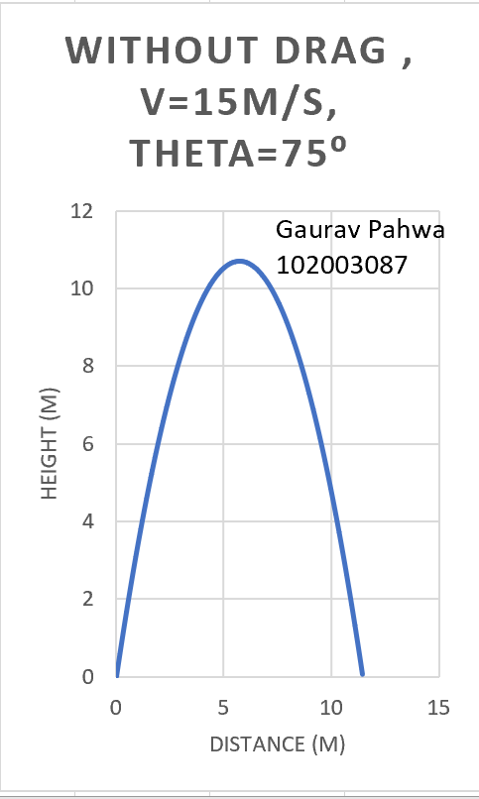

**Q(2)**

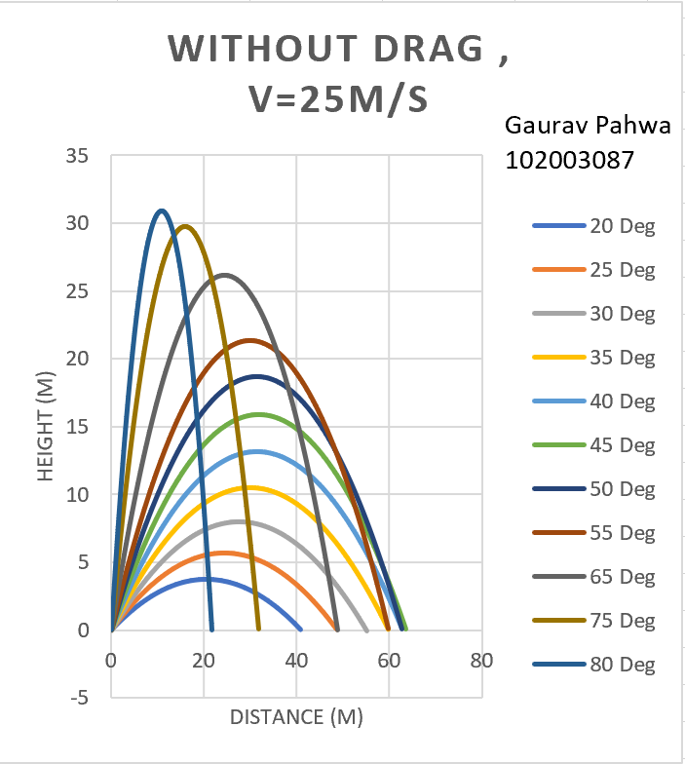

**Q3**

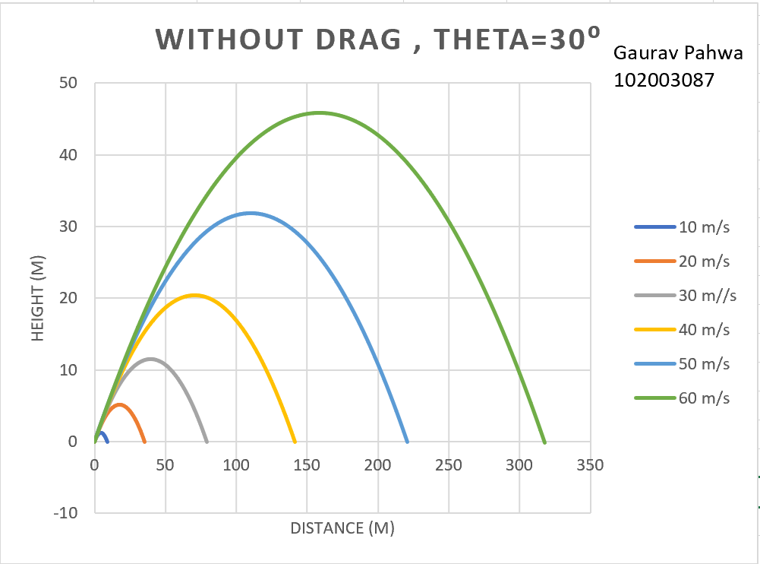

**Q4**

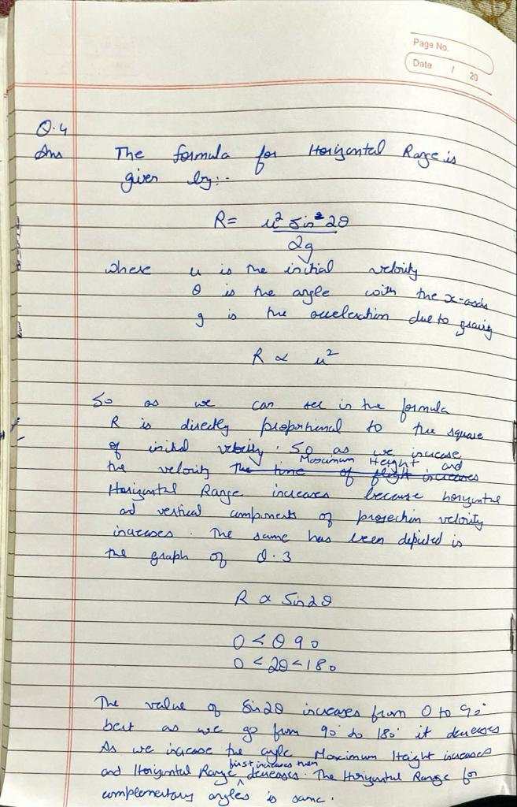

**END**